

**Green University of Bangladesh**

**Department of Computer Science and Engineering (CSE)**

**Faculty of Sciences and Engineering**

**Semester: (Summer, Year:2021), B.Sc. in CSE (Day)**

Group Project

Course Title: Database System lab

Course Code: CSE-210                 Section:193DB

**Project Name:** Student management system Project using PHP and MYSQL

**Student Details**

|  |  |  |
| --- | --- | --- |
| Name | | ID |
| 1. | Md. Nur A Neouse | 193002093 |
| 2 | Jakirul Islam | 193002101 |

Submission Date : 25.08.2021

Course Teacher’s Name : Fatema Tuj Johora

|  |
| --- |
| Project Status  Marks: …………………………………                              Signature:.....................  Comments:..............................................                              Date:.............................. |

**Student management system Project using PHP and MYSQL**

**Abstract:**

School management system project is a project in which one can manage all the activities of a school/college. This project is useful for administration of a school/college where admin can manage school activities like manage students, manage teacher, manage result, manage fee etc.

**Requirement:**

**Language used**

The frontend of the project is made by using HTML, CSS and Bootstrap.

For the backend we have used PHP, JavaScript and MYSQL.

**Software used**

We have used following basics software for the project –

1. Text editor (Atom)
2. Web browser (Google Chrome)
3. Xampp local server

**Methodology:**

In our school management system project, we have implemented almost all the basic functionality of a school/college.

We have implemented the following modules or functionality –

1. **Admin Login –**

First of all, admin have to login to admin dashboard to manage all the activities of a school/college. Admin can login to this project by using the following details –

Email id – [admin@gmail.com](mailto:admin@gmail.com)

Password – admin@123

1. **Admin Dashboard –**

When admin successfully logged into the project, he will be redirected to dashboard page. We have divided dashboard page into some sections like-

1. Student record –

This section shows the brief detail of all the students in the school/college like total number of the students, total active students and total in-active students. Admin can also see the complete list of all the student in school/college.

1. Teacher record –

This section shows the brief detail of all the teachers in the school/college like total number of the teachers, total active teachers, total in-active teachers. Admin can also see the complete list of the teacher in school/college.

1. News section –

This section shows some latest news. Here admin can show some important news related to school or college.

1. Some important links section –

In this section admin can show some important links that are related to school or students of the schools.

1. **Manage students –**

As the name of the module this module manage student’s activities where admin can manage all the activities like –

1. Add a student
2. Edit a student
3. Search a student
4. Delete a student
5. Print all students list
6. **Manage teacher –**

As the name of the module this module manage teacher’s activities where admin can manage all the activities like –

1. Add a teacher
2. Edit a teacher
3. Search a teacher
4. Delete a teacher
5. Print all teachers list
6. **Manage Result –**

This module implements result related activities like –

1. Add result
2. Search result
3. Edit result
4. Delete result
5. Print all student’s result
6. **Manage certificate –**

Manage certificate module is used to generate certificate of a student who leave the school. Admin can generate a certificate for a student and provide that certificate to the student. The certificate is auto generated.

1. **Manage fee -**

This module is used to implement fee related activities like –

1. Pay fee/Update fee status
2. Print the list of the student who have paid the fee.
3. Print the list of the student who haven’t paid the fee.

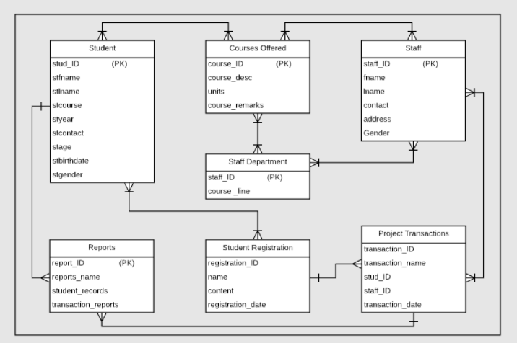 **ER Diagram:**

**Conclusion:**